

**Phone-Online-Shop**

**Final Release Document**

– Hanoi, Jul 2022 –

Contents

I. Deliverable Package 3

II. Installation Guides 3

1> Installing JDK 8u321 3

2> Installing Apache Tomcat 10.0.18 3

3> Installing Apache NetBeans IDE 13. 3

4> Integrating Apache NetBeans IDE 13 with Apache Tomcat. 3

5> Create Java Web project, Servlet and Debug. 3

6> Working with JSTL. 3

III. User Manual 3

1. Overview 3

2. Workflow 4

a. Registration 4

b. Shopping 4

c. Checkout 4

d. Order Tracking 5

e. Shopping 5

# I. Deliverable Package

| **No.** | **File** | **Notes** |
| --- | --- | --- |
| 1 | G6-OS _SRS_final.docx | Final SRS (Requirement) Document |
| 2 | G6-OS _SDS_final.docx | Final SDS (Design) Document |
| 3 | G6-OS_Project_Tracking.xlsx | Final status for the application functions, which include:  - Function name, feature, roles, function description |
| 4 | G6-OS _Issues_Report.xlsx | Final issues tracking list of the whole project |

Other related deliverables:

* Tagged source codes: https://github.com/L1N6/Project-OnlineShop.git

# II. Installation Guides

## 1> Installing JDK 8u321

Page: <https://www.oracle.com/java/technologies/downloads/>

Scroll down to find the version you need.

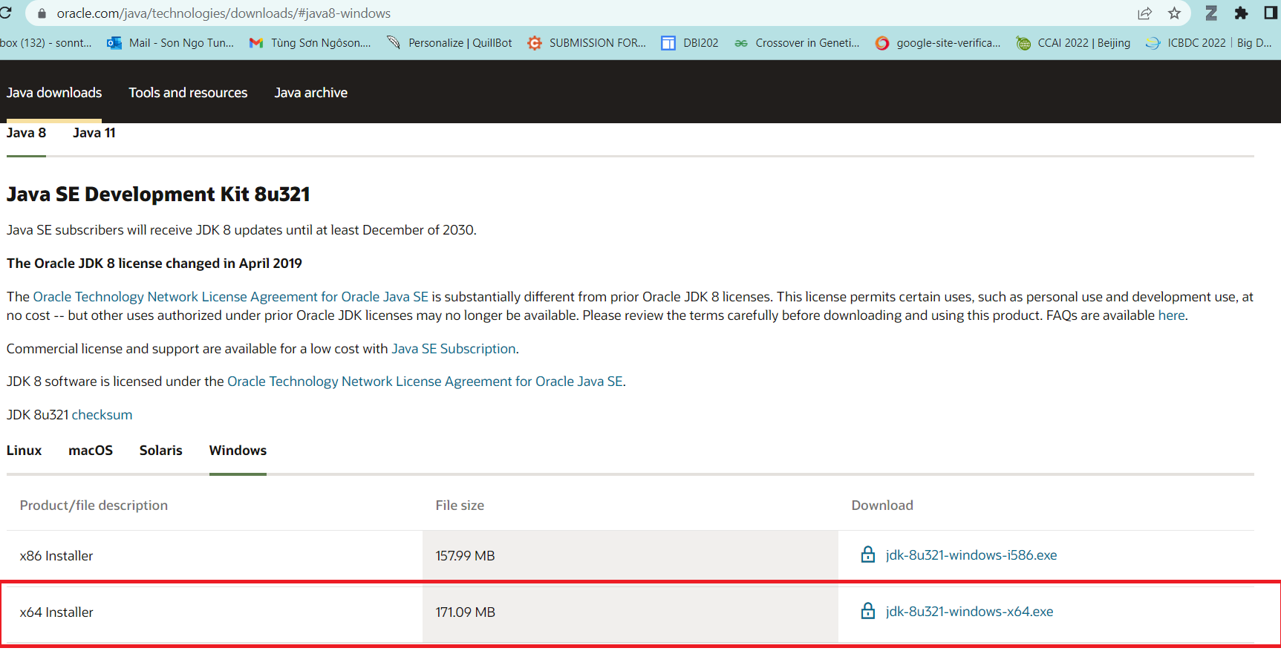

After installing, let check the installation folder:

Normally it will be located at: C:\Program Files\Java. It contains 2 folders JDK and JRE.

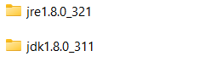

If you see these folders, it is ok for now.

For more details, you can read <https://www.oracle.com/java/technologies/javase-jdk8-doc-downloads.html>

## 2> Installing Apache Tomcat [10.0.18](https://tomcat.apache.org/download-10.cgi#10.0.18)

Download page: <https://tomcat.apache.org/download-10.cgi>

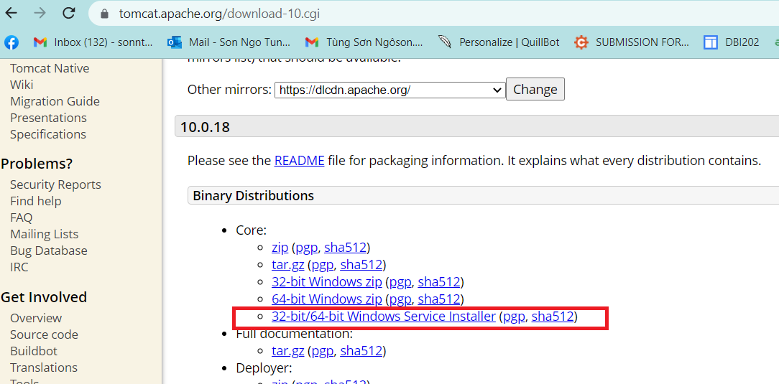

Open the installer file then click “Next” button, until you see the below screen

By default, the HTTP port is set as 8080, but I prefer to change it to 9999. You can keep it as 8080 or change it as you desire. Same for Window Service Name.

You can also set username and password at this step, but it is an optional and you can do it later.

Click “Next”, then the installer will ask you for JRE folder. Basically, the installer can automatically detect JRE folder, but in the case it cannot, you can add it manually.

Click “Next” …. Again then “Finish”.

Normally, you are going to see the below window app displayed:

It is ok, this application used to control your TOMCAT webserver, but if you do not see it, do not worry. I recommend you follow below instructions:

1. TOMCAT now is installed as a Window Service (It is a software, but it does not have a graphic user interface).
2. To work with Window Service, press window+R, fill service.msc

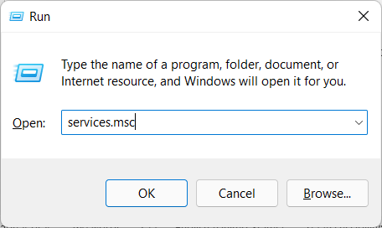

1. Find the TOMCAT service in the list:

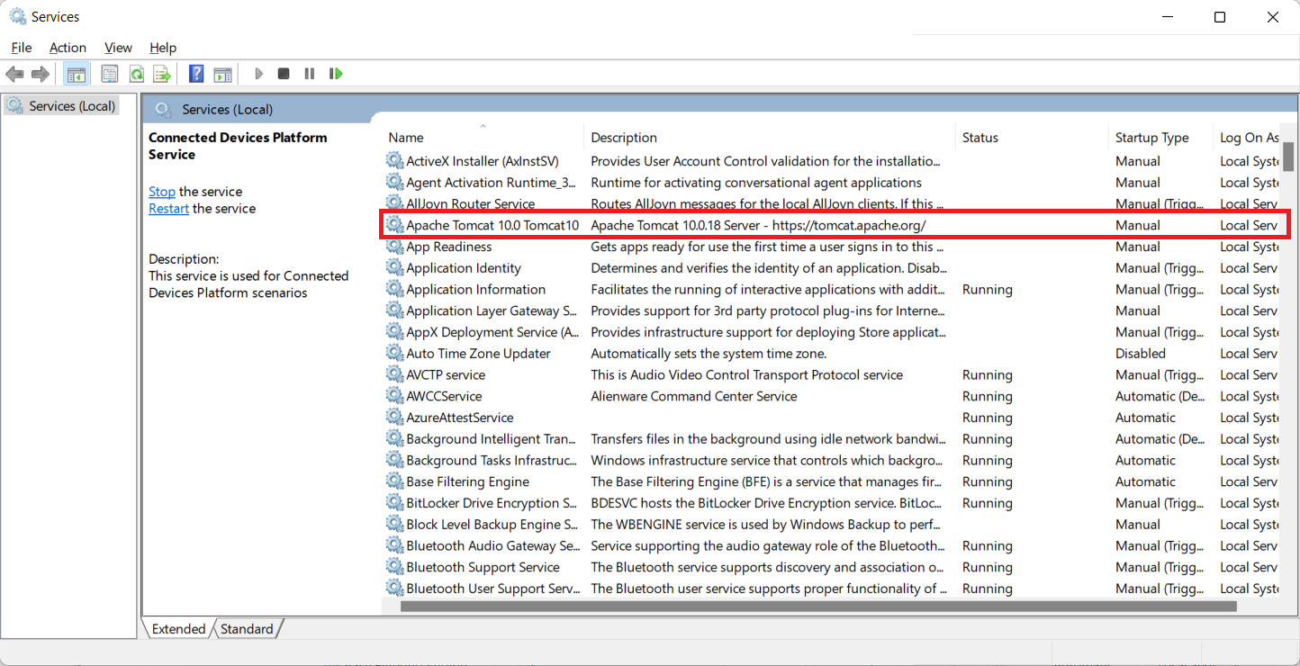

Right click -> properties ->

Now you can start/stop the TOMCAT service. Just make sure it is running before use.

You can grant permission for TOMCAT to run with Local System account on the same dialog.

## 3> Installing Apache NetBeans IDE 13.

Download: <https://netbeans.apache.org/download/nb13/nb13.html>

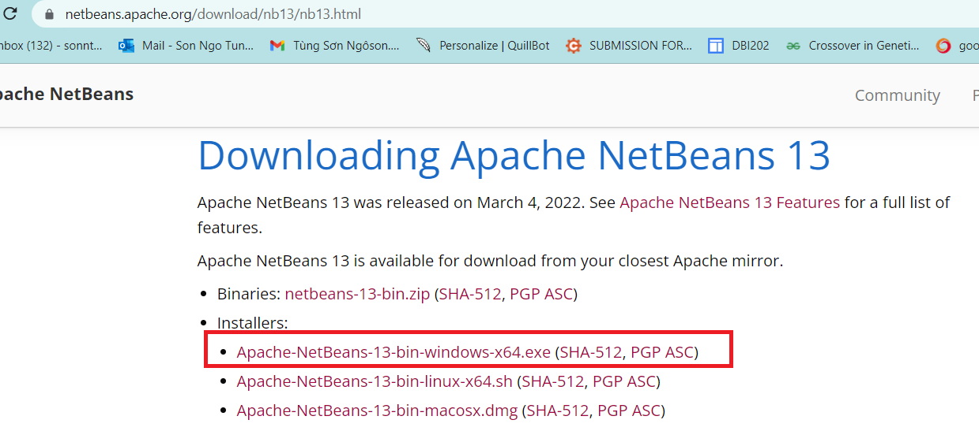

During your installation, remember to select JDK 1.8 (just in case, you have more than one version of Java).

After installation, run netbeans 13, File > New Project > Java with Ant > Select Web Application (It is disabled by default, just select it, netbeans will automatically enable the project template).

## 4> Integrating Apache NetBeans IDE 13 with Apache Tomcat.

+ First, open the Apache Tomcat folder:

By default, it is located at: C:\Program Files\Apache Software Foundation\Tomcat 10.0

The system may ask you to grant permission, just click “Yes” button. This step aims to allows your account to access the Apache Tomcat folder for further tasks.

**+** Open netbeans, on the menu bar, Window > Service (ctrl + 5) > select Service panel as following:

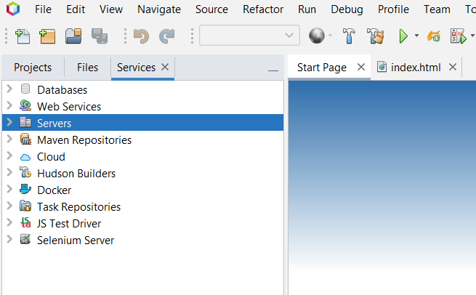

Server > Right click > Add Server > Apache Tomcat and TomEE >

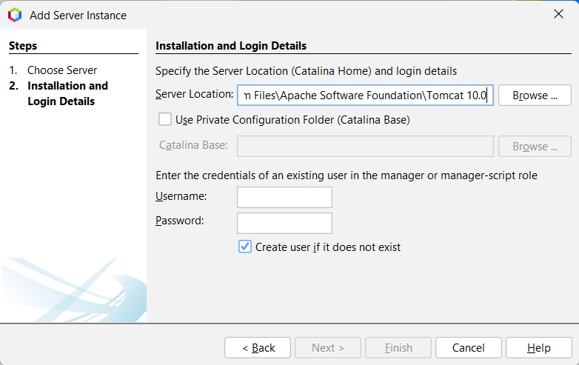

Here you can create your username and password, then finish. Now you can work with Java Web project in netbeans 13.

If you get an error related to “CATALINA_base is Invalid”, check the first step.

Errors related to Tomcat will be logged to “C:\Program Files\Apache Software Foundation\Tomcat 10.0\logs”, check the catalina**** file for the detail logs.

## 5> Create Java Web project, Servlet and Debug.

To create a new java web project: File > New Project > Java with Ant> Java Web > Web Application (See the below figure)

/// LET DO IT, IN THE SESSION OF SERVLET

Once you create new Servlet via Netbeans template file. By default, netbeans using javax, which is not included in Jarkata EE platform equipped by Tomcat 10. Just need to replace all javax by Jakarta package, then everything will be compiled.

|  |  |
| --- | --- |
|  |  |

Refer to <https://tomcat.apache.org/> for more detail

you can also edit the template file for further tasks.

**//** For one who cannot start debugging mode with apache tomcat 10. Open task manager window then kill the process of Java SE.

Check the video: <https://youtu.be/9Zcy7yWNAm4>

OR

Open window PowerShell, type command:

get-process

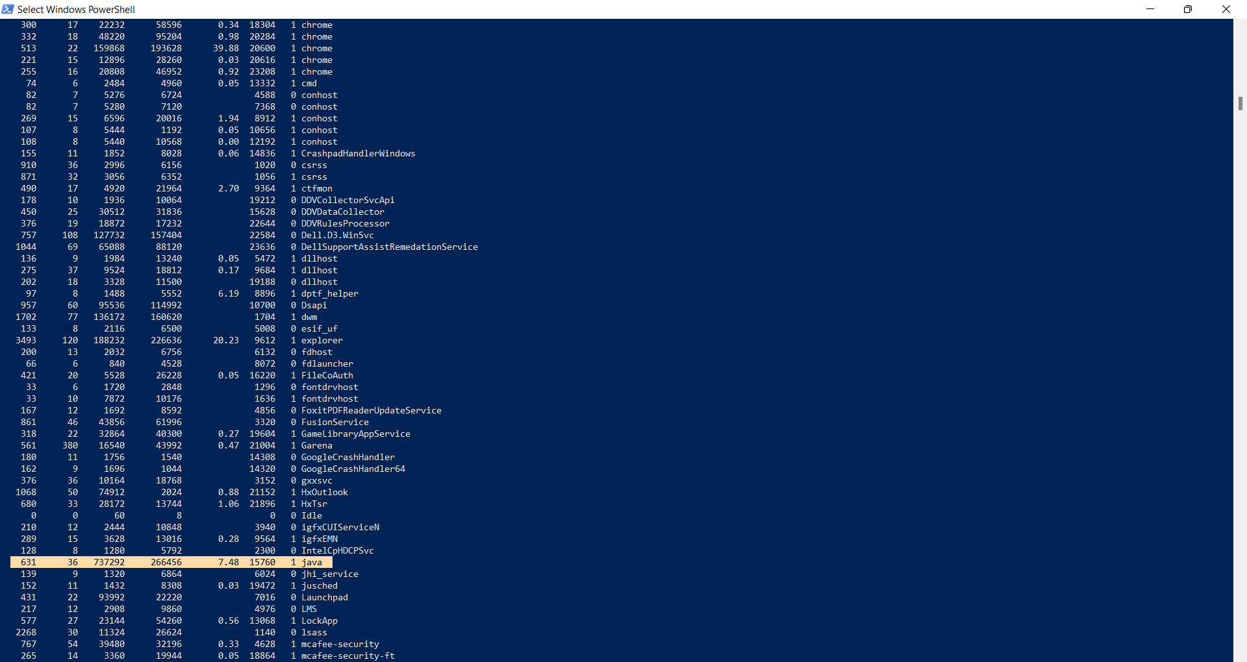

Find java-se process id, then type command:

taskkill /pid 15760 /F

Now you can try debugging again with NetBeans and tomcat.

## 6> Working with JSTL.

Latest version of JSTL build on J2EE was 1.2x. Since the Tomcat 10 is using Jakartified version (with jakarta.* package instead of javax.* package), use JSTL 2.0 to solve this dependency:

Download: Jakarta Standard Tag Library API

Link: <https://search.maven.org/artifact/jakarta.servlet.jsp.jstl/jakarta.servlet.jsp.jstl-api/2.0.0/jar>

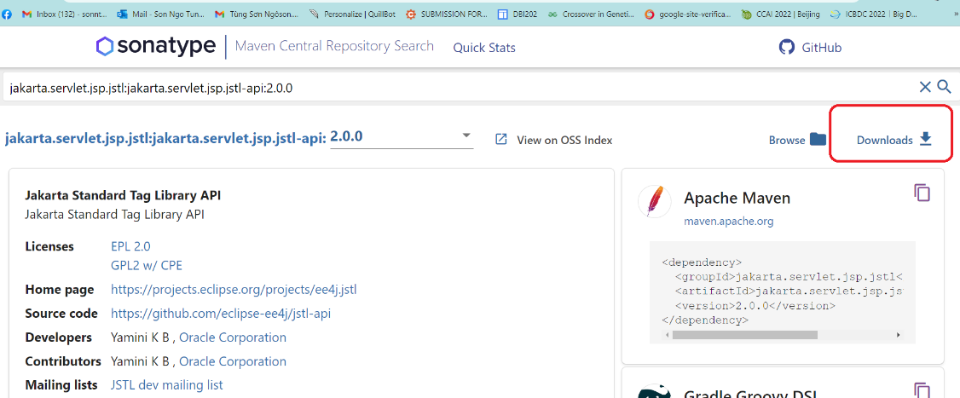

Download: Jakarta Standard Tag Library Implementation

Link: <https://search.maven.org/artifact/org.glassfish.web/jakarta.servlet.jsp.jstl/2.0.0/jar>

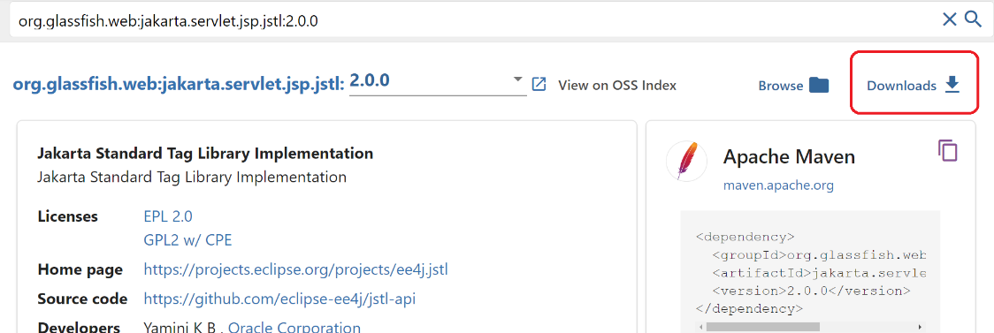

Check the document here:

<https://jakarta.ee/specifications/tags/2.0/jakarta-tags-spec-2.0.html>

# III. User Manual

## 1. Overview

- The online shop application is a platform that allows users to purchase goods and services online. The application offers a wide range of products, including electronics, fashion items, beauty products, home appliances, and groceries. The platform provides a user-friendly interface that enables users to browse, search, and purchase items easily. The application also offers secure payment options and fast shipping services, making it a convenient and reliable online shopping destination.

## 2. Workflow

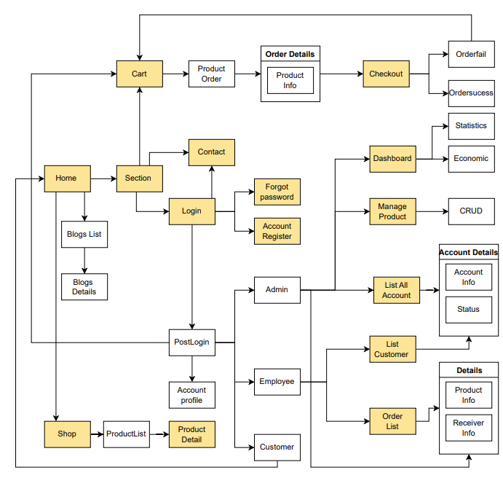

### a. Registration

- The first workflow is the registration process. Users need to create an account before they can start shopping. The registration process involves filling out a form with personal details such as name, email address, phone number, and shipping address. Once the registration is complete, users can log in to their accounts and start shopping.

- To register on the online shop application, follow these steps:

* Open the application on your device.
* Click on the "Register" button on the home screen.
* Fill out the registration form with your personal details, including your name, email address, phone number, and shipping address.
* Click on the "Submit" button to complete the registration process.
* You will receive a verification email or SMS from the application. Follow the instructions in the email or SMS to verify your account.
* Once you verify your account, you can log in to the application and start shopping.

### b. Shopping

The second workflow is the shopping process. Users can browse the various categories and products available on the platform. They can add items to their cart, view their cart, and edit the quantities of items in their cart. Once the shopping is complete, users can proceed to checkout.

* To shop on the online shop application, follow these steps:
* Log in to your account.
* Browse the categories and products available on the platform.
* Click on a product to view its details.
* If you want to purchase the item, click on the "Add to Cart" button.
* You can continue shopping and add more items to your cart.
* To view your cart, click on the cart icon on the top right corner of the screen.
* You can edit the quantities of items in your cart or remove items from your cart.
* Once you are satisfied with your shopping, click on the "Checkout" button.

### c. Checkout

- The third workflow is the checkout process. Users need to review their order, enter shipping information, and select a payment method. The application offers various payment options, including credit/debit cards, e-wallets, and cash on delivery. Once the payment is complete, users receive an order confirmation, and the application processes the order for shipment.

- To checkout on the online shop application, follow these steps:

* Review your order and make sure that all the items in your cart are correct.
* Enter your shipping information, including your name, address, and phone number.
* Select a payment method. The application offers various payment options, including credit/debit cards, e-wallets, and cash on delivery.
* Enter your payment details, if required.
* Click on the "Place Order" button to complete the checkout process.
* You will receive an order confirmation on your registered email or phone number.

### d. Order Tracking

- The fourth workflow is the order tracking process. Users can track their orders and view the estimated delivery time. The application provides real-time updates on the status of the order, from the time it is shipped until it is delivered.

- To track your order on the online shop application, follow these steps:

* Log in to your account.
* Click on the "Orders" tab in the menu.
* You will see a list of all your orders. Click on the order that you want to track.
* You will see the details of your order, including the shipping status and estimated delivery time.
* You can also track your order in real-time by clicking on the "Track Order" button.
* Once your order is delivered, you will receive a notification on your registered email or phone number.

### e. Contact

- Contact flow refers to the path that a customer takes when they contact the customer service or support team of a business. A contact flow is designed to provide customers with a smooth and efficient experience by guiding them through a series of steps to resolve their issues or concerns.

- The following are the typical steps involved in a contact flow:

* Welcome Greeting: The customer is greeted with a welcome message and prompted to select the appropriate option to proceed.
* Interactive Voice Response (IVR): The customer is presented with a series of options that they can choose using the keypad on their phone. This helps to direct the customer to the appropriate department or agent to handle their request.
* Queue: If there is a high volume of calls, the customer may be placed in a queue and informed of the estimated wait time.
* Agent Connection: The customer is connected to an agent who can assist them with their request. The agent may ask for the customer's account information or other details to verify their identity.
* Issue Resolution: The agent works with the customer to identify and resolve their issue or concern. The agent may provide instructions, troubleshoot problems, or offer solutions to the customer's issue.
* Closing: Once the issue is resolved, the agent will confirm that the customer is satisfied with the solution provided and ask if there is anything else they can assist with. The call is then closed, and the customer is thanked for their time.